Richard Patrican, Andrew Cedeno, Nathan Jordan
BENG 493
HW 1 – Test/Experimental Plan

- In regards to previous tests or experiments performed in the past semester, none. Meaning, the focus of the past semester was in the design and production of the SprAid prototype, which did not include testing procedures on the device or solutions.
2) Cell Testing

Protocol procedures for cultivation of Primary Adult Murine Keratinocytes (Option 1)

Materials
- Instruments
- Two Kelly forceps with a blade end style of a curvature nature.
- Surgical scalpel blade with blade cutters of number 22.
- Sterile scissors.
- Adult Murine Skin
- Adult mouse tails (C57B6/J) that have a prevalent life span of ≥ 8 weeks.
- Reagents
- Sterile filtration measures must be applied to all reagents at a set parameter of 0.22 µm, then stored at a set temperature of 4°C. However, the reagents must be stored in an ice chamber throughout the remainder of the experiment, unless the protocol states otherwise.
C.1 Skin processing
1. Povidone-iodine solution in the amount of 10% of available iodine which is equivalent to 1% w/v iodine.
2. Into 1 L of PBS-AF (phosphate buffer saline with antifungal and antibiotic agents), add 10 mL of penicillin/gentamycin and 3 mL of Fluconazole. Penicillin (600 µg/mL, meaning for every 1 mL contains 600 µg of Penicillin), gentamycin (8 mg/mL) and Fluconazole (2mg/mL).
3. In regards to the dispase solution, add the neutral dispase II (8 mg/mL, Roche; cat. No. 165 859) into PBS-AF. Sterile filtration of the mixture at a set parameter of 0.22 µm before using the mixture.
C.2 Isolation of basal keratinocytes
1. Trypsin-ethylenediamine tetraacetic acid (EDTA) (Thermo Trace Ltd.; cat. No. 21- 160-0100V).
2. Trypsin inhibitor in the amount of 0.5L: DMEM without the use of calcium (Note: An alternative medium can be used to replace DMEM as long as the removal of Ca²⁺ is taken into effect. Ca²⁺ removal is essential to the protocol considering, murine keratinocytes are sensitive to fluctuating concentrations of Ca²⁺); BSA or bovine serum albumin in the amount of 0.5 g; and soybean trypsin inhibitor (Sigma; cat. No. T9003; amount 0.1 g).
C.3 Serial culture of Adult Murine Keratinocytes
1. Collagen type IV from a human placenta (Sigma; cat. No. C5533); prepare the collagen stock solution of 1 mg/mL into 10 mM acetic acid (Note: Formulating the stock solution requires the placement of 10 mM acetic acid into the stock solution slowly along with swirling the contents. Once the content of the stock solution has been swirled, leave the solution in an isolated freezer set at 4°C to allow for solubilization. The collagen stock solution must maintain a cold condition to prevent polymerization from setting into the solution).
2. The acquisition of 0.5 L of Adult mouse keratinocyte growth medium (AM-KGM): Keratinocyte basal medium (KBM) (Clonetics, San Diego, CA; cat. No. CC-3101; 500 mL), hydrocortisone (0.5 mg/mL in abs. ethanol, Sigma; cat. No. H0135; 500 µL), epidermal growth factor (100 µg/mL in PBS-AF/1% BSA, Sigma; cat. No. E4127; 50 µL), Bovine Pituitary Extract (BPE) (35 mg/mL, Hammond Cell Tech, cat. No. 1077; Note: Concentration of proteins can fluctuate from batch to batch. Therefore, the processing of the extract calls for the assaying of the protein concentration immediately after, according to the parameters laid out by the manufacture. Once the assaying has been completed, add the portions into vials to allow a reasonable protein concentration of 70 µg/mL to be reached, then added into 500 mL medium; 1 mL), BSA in the amount of 1 g, ITT (500X stock solution; 1 mL). The preparation of 10 mL: insulin (6.25 mg/mL in 12 mM HCl, Sigma; cat. No. I1882; 4 mL), transferrin (25 mg/mL in ddH₂O, Sigma; cat. No. T8158; 1 mL), triiodothyronine (T₃, 4 x 10⁻¹⁰ M, Sigma; cat. No. T5516; 5 mL).

The preparation of 10 mL:
- In 50 mL 0.02 N NaOH, place 13.6 mg T₃ into the mixture to allow T₃ to dissolve.
- Dilute 50 µL T₃ by placing into 5 mL of ddH₂O (4 x 10⁻⁶ M).
- Dilute 100 µL of 4 x 10⁻⁶ M T₃ by placing into 9.9 mL of ddH₂O (4 x 10⁻⁸ M).
- Dilute 100 µL of 4 x 10⁻⁸ M T₃ by placing into 9.9 mL of ddH₂O (4 x 10⁻¹⁰ M).
- EOP (500X stock solution): 1 mL. For the preparation of 10 mL, 30 µL of ethanolamine (Sigma; cat. No. E0135) will be added to 10 mL of ddH₂O (50 mM). 70.55 mg of o-phospho-rylethanolamine (Sigma; cat. No. P0503) will be dissolved into 10 mL of 50 mM ethanolamine.
- Selenium (2.65 x 10⁻⁸ M in ddH₂O, Sigma; cat. No. S9133; 1 mL).
- Adenine (500X stock solution; 1 mL): For the preparation of 10 mL, 0.121 g of adenine (Sigma; cat. No. A2786) will be dissolved into 5 mL of 4 N NaOH. 10 mL can be created in KBM (90 mM).
- Progesterone (500X stock solution; 1 mL): For the preparation of 10 mL, 1 mg of progesterone (Sigma; cat. No. P8783) will be dissolved into 2 mL ddH₂O. 62.9 µL of 0.5 mg/mL progesterone will be added into 10 mL ddH₂O (3.15 x 10⁻³ mg/mL). 1 mL of 3.15 x 10⁻³ mg/mL progesterone will be added into 9 mL KBM (1 x 10⁻⁶ M). The corresponding elements will be added: 50 µL Cholera toxin (1 mg/mL in ddH₂O, Sigma; cat. No. C8052); 100 µL Isoleucine (250 mM in 1 N HCl, Sigma; cat. No. I7403, Note: In regards to the questionability of amino acids for solubilization, they require slow vortexing and minor heating in order for the process of solubilization to take full effect. Precipitates that appear after a prolonged cycle of heating and vortexing upon the condition of thawing frozen aliquots, are proceeded by the following step: discarding the vial and in place using a fresh vial.); 125 µL Tyrosine (124 mM in 1 N HCl, Sigma; cat. No. T8566); 200 µL Tryptophan (37.5 mM in 1 N HCl, Sigma; cat. No. T8941); 500 µL Histidine (230 mM in ddH₂O, Sigma; cat. No. H6034); 2 mL Alanine (1.02 M in ddH₂O, Sigma; cat. No. A7469); 2 mL Threonine (312.5 mM in ddH₂O, Sigma; cat. No. T8441); 1 mL Penicillin (600 µg/mL)/gentamycin (8 mg/mL).
- 1.5 mL Fluconazole (2 mg/mL solution; Pfizer).

- KBM and hydrocortisone must be regulated in an isolated environment away from natural light at a temperature of 4°C. All remaining supplements are regulated in a controlled environment at -20°C. However, EGF and BPE can maintain their viability when placed in an isolated environment of -80°C for up to one year. The proceeding components of the protocol will all be sterile-filtered at a set parameter of 0.22 µm and then aliquoted for storage. In regards to the medium, sterile filtration will be performed once all corresponding components have been added, thus will follow set parameter as recently stated. The need to perform repeated measures of filtration is not advised.
- EDTA: 0.05% w/v in PBS-AF.
- Trypsin-EDTA and trypsin inhibitor as per isolation procedure.
- Trypan blue solution: 0.4% (Sigma; cat. No. T8154).

- Method
- Processing of Skin
- Adult C57B6/J mouse, will be terminated by the process of inhalation anesthesia. The process is then followed up by cervical dislocation, then the contents of the mouse is placed inside a box under a biohazard laminar flow hood.
- Place the mouse on the inverted lid side of a sterile 100-mm petri dish. Target the proximal end of the tail with the scalpel, then cut 3 mm away from the body to remove the tail.
- Once the tail has been removed from the body, place the tail into 10 mL of povidone-iodine solution cap. Securing the tail into the solution cap, the user will then proceed in a clockwise rotation in a 12 to 6 fashion several times.
- Remove the tail from the solution cap and then transfer it to 10 mL of PBS-AF cap. Once the tail is secured in the solution cap proceed by moving the tube in a clockwise rotation starting from 12 and ending at 6. Return to 12 and rotate to 6 in the same fashion several times.
- Remove the tail from the solution cap and then proceed by placing it into 10 mL 70% ethanol cap. After the tail is secured in the solution cap, proceed by rotating the tube in a 12 to 6 fashion several times.
- Remove the tail from the solution cap and then transfer it into 10 mL PBS-AF cap. Securing the tail into the solution cap, rotate the tube in a 12 to 6 fashion several times in order to rinse off the residual ethanol. The process of rotating the tube after several times will be repeated.
- Remove the tail from the solution cap and place on an inverted side 100 mm sterile petri dish. Using forceps, hold the proximal end of the tail. Upon holding the tail with the forceps, make a small incision at the severed end by the use of the scalpel.
- From the small incision made by the scalpel, apply the forceps to the incision area to open out the area to create a 1 cm flap.
- A continuation of the proceeding procedure, the use of forceps must be applied by firmly grasping the underlying tissue layer of where the incision was made. The underlying layer is defined as the cartilage. Once the user has a firm grasp of this area, proceed by taking a second pair of forceps and peeling off the skin at the distal end of the tail (Note: If the forceps are insufficient to perform the desired function of skin removal, sterile ethanol sprayed gloves may be used to remove by mechanical force the skin layer). Place the skin layer into a 100 mm petri dish containing PBS-AF that is then placed on ice.
- After the tail has been peeled, section off the tail into three equal lengths by the use of the scalpel. However, in regards to more broad proximal pieces, cut the pieces lengthwise to produce approximately four equally size pieces. Once the tail has been sectioned off along with the proximal pieces cut into equal sizes, place all remaining pieces into a separate 100 mm petri dish of PBS-AF on ice.
- All remaining tail pieces will be placed into a 60 mm petri dish containing 10 mL dispase that will then be incubated overnight at 4°C with parafilm wrap on top to seal the petri dish.
- Isolation of Basal Keratinocytes
- 15 mL of trypsin inhibitor will be aliquoted and retained on ice.
- 10 mL of trypsin-EDTA will be aliquoted and then transferred into a 100 mL sterile beaker. Place into the beaker a magnetic stirring bar and cover the container with parafilm. Once the container is sealed, preheat the plate to 37°C and place the beaker onto the plate for 15 minutes.
- Dispase tails will then be taken out of there containers and transferred to a 100 mm petri dish of PBS-AF. The tails will sit in the solution where the process of rinsing will take place.
- One by one take the skin pieces from the petri dish and place the skin layer on the inverted lid side. Orientation of the skin layer will be presented on the lid in the following way: dermal side facing down and epidermal facing up. The use of the forceps will then be applied to the corner area of the skin layer, where the user will firmly grasp the corner, while taking the other pair of forceps and gently peeling off the epidermis in the direction of the hair follicle. After the epidermis has been peeled away from the dermal layer, transfer the epidermal piece into fresh PBS-AF to complete the process of rinsing. The treatment of applying the skin layer to dispase, was to allow easier and more functional removal of the epidermal from the dermal layer while maintaining viable follicular structures along with preventing loss of hair follicle keratinocytes.
- Line up the epidermal pieces alongside one another at the center of lid, where the use of the scalpel will be used to cut the epidermal into pieces of four or five along their length.
- Epidermal pieces will then go through a stage of release, meaning, each piece will be pressed down against the lid in order to facilitate the release of excess PBS-AF from the epidermis. Once the process of release has been completed, transfer the pieces from the lid side into pre-warmed trypsin-EDTA. Immediately after all pieces have been transferred, place onto a magnetic stirring plate for 4 minutes at an rpm rate of 500.
- Once the process of magnetic stirring has been completed, transfer the vessel into a container filled with ice. Proceeding the placement of the vessel into the container, add an equal volume of cold trypsin inhibitor to the vessel.
- One 25 mL pipet will be used to aspirate the epidermal slurry and transfer it through a 70 µm cell strainer (Becton Dickenson). However, in order to prevent the blockage of the pipet during the process of aspiration, cut off 5 mm from the tip of the pipet using a pair of scissors. The slurry will then pass through the 70 µm cell strainer into a 50 mL Falcon tube.
- The process of filtration suspension will be repeated, but under the conditions of using a 40 µm cell strainer into a new 50 mL Falcon tube. Upon completion of the filtration suspension, allow 5 mL of trypsin inhibitor to pass through the strainer in order to facilitate the pickup or collection of residual cells leftover in the strainer.
- Centrifuging will take place under the following conditions: 5 minutes at 4°C undergoing a spin rate of 400g. Remove the supernatant and gently flick the side of the tube in order to prevent the anchorage of the pellet at the bottom of the tube. Once the pellet is no longer anchored to the bottom of the tube, re-suspend in 1 mL of AM-KGM and pipet continuously in order to break up residual clusters. The process is then followed by the addition of 15 mL of cold medium.
- Proceeding from the previous step, take a small portion of the cell suspension and dilute the mixture into an equal volume of 0.4% Trypan blue. Counting of cells will done by the use of a hemocytometer. The cell viability will range from 85-90%, whereas the approximate basal keratinocyte concentration will be within the range of 6-8 x 10⁶ per tail.
- Serial Culture of Adult Murine Keratinocytes
- Primary Culture
- In regards to cell isolation, precautionary steps must be taken before isolation proceeds: coating the entire tissue culture flasks with 20 µg/mL collagen IV in PBS-AF. (Note: Coating the flasks before isolation is recommended due to the higher response rate of cultures when applied with collagen IV coated substrates.) Once the coating has been completed, incubate the tissue culture flask for 3 hours under 37°C or 4°C for overnight purposes. Aspirate or suction out the collagen from the tissue culture flask followed by washing with PBS-AF.
- Seeding of the cells is done by the placement of the cells onto collagen coated substrates in AM-KGM at the set cell density parameter. Parameter can range from 1-10,000 cells/cm². (Seeding: Splitting of the cells into different concentrations for desired results)
- Optional part of the experiment, to improve the prospect of plating efficiency, centrifuge inoculated plates at a rate of 200g at 4°C for approximately 5 minutes.
- Plates will then be incubated at a temperature of 37°C, with a CO₂ concentration of 5%.
- Leave the plates within the incubator for three days. The third day requires a removal process of dead and differentiating cells. The process of removal is done by pipetting the medium up and down. Thereafter, fresh medium will be added for a total of 3 times per week along with the removal process by pipette. However, when confluence rates are reached, cultures must be supplied with a medium on a daily basis and no longer 3 times per week. The process of feeding, once confluence has been reached, is to prevent the cells from a state of differentiation.
Protocol procedures for cultivation of E. coli in a liquid media (Option 2)
- Inoculating loop
- Process of sterilization must be accounted for by placing the wire closet to the handle into the flame of the Bunsen burner. Maintain the presence of the wire in the flame until the wire glows red.
- Once the wire glows red near the handle, proceed by placing the rest of the wire slowly through the flame until each section of the wire and loop glows red.
- In order to cool the surface of the loop, place the loop by holding onto the handle with one hand and placing the loop into an unused section of the solid medium of the agar plate.
- Culturing Bacteria on Solid Media
- Note: E. coli can grow in colonies within the solid medium of an agar plate. The process of reproduction is asexual, in which a signal colony growth is the response of a single bacterium reproducing asexually. Due to the reproduction nature, each of the cells in the colony have the same genetic identity, therefore classifying them as clones.
B1. Streaking a culture on a plate
- Place the inoculating loop into a solid culture of E. coli bacteria. Make sure a significant amount of material is enough to cover the loop. Note: In the process of covering the loop, ensure that the material of E. coli covering the loop is a thin and equal surface.
- Once placing a thin layer of E. coli onto the loop, streak the surface of the agar plate. By moving the loop on the surface of the agar in a zigzag pattern for a total of five times.
- Completion then calls for the sterilization of the loop by placing the loop into the flame of the Bunsen burner.
- Placement of the loop into the burner is then proceeded by placing the loop into an unused section of the agar in order to cool. Once the cooling process is complete, in regards to the loop, place the loop back into the agar of the first streak. From the first streak move in a zigzag pattern parallel to the first streak. Repeat the motion of the streak in a zigzag pattern for a total of five times.
- Once the second streak is complete, place the loop back into the burner for sterilization. After sterilization, place the loop into the same unused section of the agar in order to cool.
- Repeat the process until there are a total of four to five streaks on the agar plate.
- The streaking process completion, then calls for the user to place the agar plates into the incubator at a temperature of 37 degrees Celsius. Note: Place the agar side of the plate facing up and not down. The reason for the particularity in placement is due to condensation formation on the plates during the process of incubation. Leave the plates in the incubator overnight.
- Repeat steps 1-7 for the preparation of 6 more agar plates. In total the user will have 7, solid media agar plates with E. coli bacterium.
- Growing Bacteria in Liquid Culture
C1. Inoculation and Growth of Small Batch Cultures (Small Culture <10 mL)
- Place the sterile loop into a single isolated colony of the incubated agar plate and scoop out the isolated colony.
- Insert the loop, with the contained isolated colony and place the material above the liquid within the test tube.
- Place the test tube into the incubator at 37 degrees Celsius and leave overnight.
C2. Growth of Large-Volume Cultures
- In order to grow larger cultures of a size of 1 liter, a starter colony is grown within 10 mL of LB overnight.
- The starter colony is then placed into a larger volume setting with additional LB added and then placed in the incubator at 37 degrees Celsius overnight.
C3. Monitoring Growth in Liquid Medium
- The process of E. coli bacterium growth has four general phases including: lag, exponential/logarithmic, stationary and death.
- The process of lag phase, exhibits no net growth. The reason for this phenomenon is due to E. coli’s adjustment to the medium.
- Exponential growth phase, is the process in which the bacterium has adjusted to their environmental settings. The process of adjusting has allowed the bacterium to increase in colonization and growth rates exponentially.
- Stationary phase, due to the exponential increase in growth rates of the bacterium, the bacterium at this phase has diminished all sources of nutrients. Due to this, the bacterium is no longer growing but instead accumulating toxic byproducts.
- Death of the bacterium is exhibited due to depletion of cellular energy or the formulation of autolytic enzymes. Note: The process of cell growth dealing with the four phases can be determined accurately by measuring the cell number within a specific cell culture.
C4. Hemocytometer (Petroff-Hausser cell counting chamber)
- Based on the procedure above, utilize the cell suspension already prepared and place in a balanced salt solution. The solution used will be Hank’s Balanced Salts [HBSS].
- Utilizing a Pasteur pipette, transfer 0.5 mL of 0.4% Trypan blue to a 5 mL test tube. Upon completion, add 0.3 mL of HBSS, 0.2 mL of cell suspension into the 5 mL test tube and mix thoroughly (Dilution factor = 5). Note: Before continuing, allow the contents in the test tube to sit for a total of 5 to 15 minutes. However, do not exceed this time frame because Trypan blue can end up staining both viable and non-viable cells. Trypan blue has been developed to only stain viable cells and not, non-viable cells.
- Once the cover slip is in place, transfer a small amount of the cell suspension from the 5mL test tube prepared in step 2 into both chambers of the hemocytometer. In the process of loading the cell suspension into the hemocytometer, adequately fill the chambers, but do not overfill or underfill.
- Stated before, trypan blue will stain viable cells, not non-viable cells. In the process of counting cells, make sure to keep a record of both viable and non-viable cells.
- Beginning with chamber 1 of the hemocytometer, count all the cells located in all 4 corner 1mm squares including the middle 1mm square. Remember to count both viable and non-viable cells.
- In the process of counting cells in the appropriate squares, focus only on the cells touching the middle line of the top and left sides of the square.
- Once the process of cell counting is completed for all 4 corner squares and middle square dealing with chamber 1, repeat the process found in steps 3-6 for chamber 2.
- Continue the process found in steps 1-7 dealing with a second sample in order to ensure the accuracy of cell counting.
C5. Calculations
- Cell counts: In regards to the total volume of each square including the cover slip of the hemocytometer, the calculated volume is 0.1mm³ or 10-4 cm³. Note: 1cm³ is equivalent to 1mL.
- Cells Per mL: average count per square x dilution factor x 10⁴: Example; If the average count per square is 45 cells x 5 x 10⁴ = 2.25 x 10⁶ cells/mL
- Total Cells: Cells per mL x Original volume of fluid from which the cell sample was removed: Example; 2.25 x 10⁶ (cells/mL) x 10 mL (original volume) = 2.25 x 10⁷ total cells
- Cell Viability (%): [total viable cells (unstained)/ total cells (stained and unstained)] x 100: Example; If the average cell count for viable cells (unstained) per square is 37.5, then the total viable cells = [37.5 x 5 (dilution factor) x 10⁴] viable cells/mL x 10 mL (original volume) = 1.875 x 10⁷ viable cells. Cell viability (%) = [1.875 x 10⁷ viable cells/ 2.25 x 10⁷ (total cells)] x 100 = 83% Cell viability
C6. Three medicated solutions applied to the solid media agar plates
- Note: The three solutions include; Antiseptic plus an anesthetic, Hemostatic agent, and a Thermoregulator (Spray on Band-Aid).
- Once the solid media agar plates have completed the last step dealing with inoculation the antiseptic plus an aesthetic will be applied to the surface of 2 agar plates by aerosol.
- After the process of spraying is complete and the entire surface is covered with a thin layer of solution stop. Proceed then by completing steps C1-C5.
- The next 2 agar plates will be sprayed with a Hemostatic agent, in the same manner as discussed in step 3. Once the process of spraying is complete for both agar plates, continue by completing steps C1-C5.
- Place the remaining 2 out 3 agar plates in front of you and spray the Thermoregulator to the surface of both agar plates. Remember: only spray until the surface of the agar is covered with a thin layer. Continue by completing steps C1-C5.
- The last agar plate will have all 3 solutions on the surface of the agar plate. Spray each of the solutions onto the surface. However, make sure each solution is sprayed just long enough to cover the surface of the agar. Proceed then by completing steps C1-C5.
In regards to both options, option 2 will be selected as a first choice candidate and option 1, will act as a fallback plan. The fallback plan will be put into place if any predicaments arise in which the prime directive of the desired outcome of the cell testing experiment is not achieved. The outcome of the cell testing procedure as detailed in option 2, is designed to grow live bacterium in a controlled setting and to measure and count the proliferation of those cells. However, the purpose of the experiment is to test each of the three solutions including: Antiseptic plus an anesthetic, Hemostatic agent, and a Thermoregulator (Spray on Band-Aid). The experiment will call for four phases of the experiment. Phase one calls for the preparation and incubation of solid media bacteria such as E. coli within a controlled setting provided by Dr. Wu in Prince William. Phase two, once 7 solid media agar plates with fully propagated bacteria are ready, each solution will be applied independently to 2 of the agar plates. Therefore, each solution will be applied to 2 of the agar plates. Phase 3, each of the agar plates will undergo the process of liquid culturing (C1-4) followed by cell counting and calculation measurements (C5). Phase 4, is the process of adding all 3 solutions to the seventh agar plate. Phase 4 will act as an ideal scenario in the sense of the agar acting as the lining of the epidermal layer of a human patient. By adding all 3 solutions, the user will determine if the solutions maintained a system comparable to that of the skin. Meaning, results should prove that by the addition of each of the solutions at once, the bacteria was eradicated and a thin thermoregulator protecting the agar from the outer elements prevents future bacterial growth.
The process of experimental cell testing will initialize a hypothesis stating: If the chemical identities known to the user are fundamental in the healing process for epidermal bacterial infections, each of the solutions should prove to have a positive effect on the overall healing rate. Meaning, if the process is successful, the results should show in regards to bacterial cell count, a low yield. Therefore, the question driving the experiment is, whether or not the solutions introduced and utilized by our SprAid device, has a positive effect in treating common bacterial infections when present on the surface of a skin layer, in which case the agar. The protocol presented as option 2 will provide a sufficient measure in which to answer with definitive proof on whether the question is true or false.
In response to completion criteria and special considerations, several factors will be discussed addressing both issues simultaneously. In regards to completion, cell testing protocol requires the user to incubate the agar plates overnight, but to monitor the growth of the solution on a daily basis. However, since all 7 agar plates will be prepared at once the process of completing this step will take 5-6 hours. Phase 2 and 3 will require a full day’s work in the lab in order to complete the process along with the calculations. Phase 4 will act as an independent test day, testing the hypothesis and question formulated in the above section. Phase 1-4, should take approximately 3 days to complete. But, if procedural errors or time restrictions occur during the process, than the expected time in which cell testing will be completed is 5-7 days. Special considerations in which must be noted include, the time frame of all available team members, availability of lab time, resource and stock availability and backup plans set in place if team members or lab time is unavailable. Each of the members of the group and advisor must be in tuned and in direct contact at all times in order to fulfill and complete the cell testing process. Since the lab is in Prince William and deemed a closed facility to outside civilians, measures must be taken in order to access and require entrance into the lab freely in order to complete the required test within the allocated time. Setting up a daily itinerary will help resolve these issues along with setting up a daily meeting with our advisor addressing certain issues, results or problems with the experiment.
The expected measurements and results coincide with the calculations (C5) presented in option 2 of the protocol. Noted previously in the document, phases of growth can be determined by cell counting. By following the parameters described in C5, the user can obtain information in regards to cells per mL, total cells and cell viability %. When testing the cell viability for phase 4 of the experiment, the cell viability should produce a result in the range of 0-5%. The reason for this range is due to the nature of the Antiseptic plus aesthetic and Thermoregulator when applied to the surface of the agar. The antiseptic will neutralize a significant percentage of the bacterial population and the Thermoregulator will prevent the spawning of new bacterial growth. In essence, the user will see a low viability cell count of E. coli. However, if the results show a high cell viability then a procedural error was made along with a contamination factor which was not previously perceived during the process of the experiment. Therefore, a high death rate of E. coli should be visible during the process of the experiment which correlates to a low cell viability %.

Mechanical Testing

Protocol for Pressure testing SprAid device
- Pressure Measurement of the barrel
- The first step is to acquire two fixed points on the barrel. Note: Since the barrel is constant in diameter and shaped in an L format, the pressure being supplied by the CO₂ canister will be measured only from the point of intersection to the exit valve of the spray nozzle. In other words, pressure will only be measured along the main line of the barrel from the intersection to the spray head.
- Once both points have been established, measure the height of the point starting from the base of the spray handle to the point (P1). Proceed by completing the same step for the second point (P2).
- Connect the pressure gauge into the barrel at the first point (P1) and measure the amount of pressure in ATM (atmospheric pressure). Continue to take readings until the CO₂ has been depleted. Note: Write down the elapsed time of how long it takes to deplete the current CO₂ canister.
- From the data collected, calculate using Bernoulli’s equation, the pressure at point (P2) in units of pounds per square inch (p.s.i). Remember, since the diameter of the tube is constant as in the example (Fluid flow through a constant diameter pipe) provided below, both terms cancel out on both sides of the equation.
- Last, change the position of (P2) to the spray head, however, do not change the position of (P1). Measure the height of (P2) from the base of the spray head to the point. Next, measure the pressure at (P1) using the pressure gauge in units of ATM. Note: Write down the elapsed time of how long it takes to deplete the current CO₂ canister.
- Repeat step 4, noting however that the diameter of the tube has changed and is no longer constant. Rely on example 2, to guide you through the calculations in calculating pressure at point (P2) in units of (p.s.i).
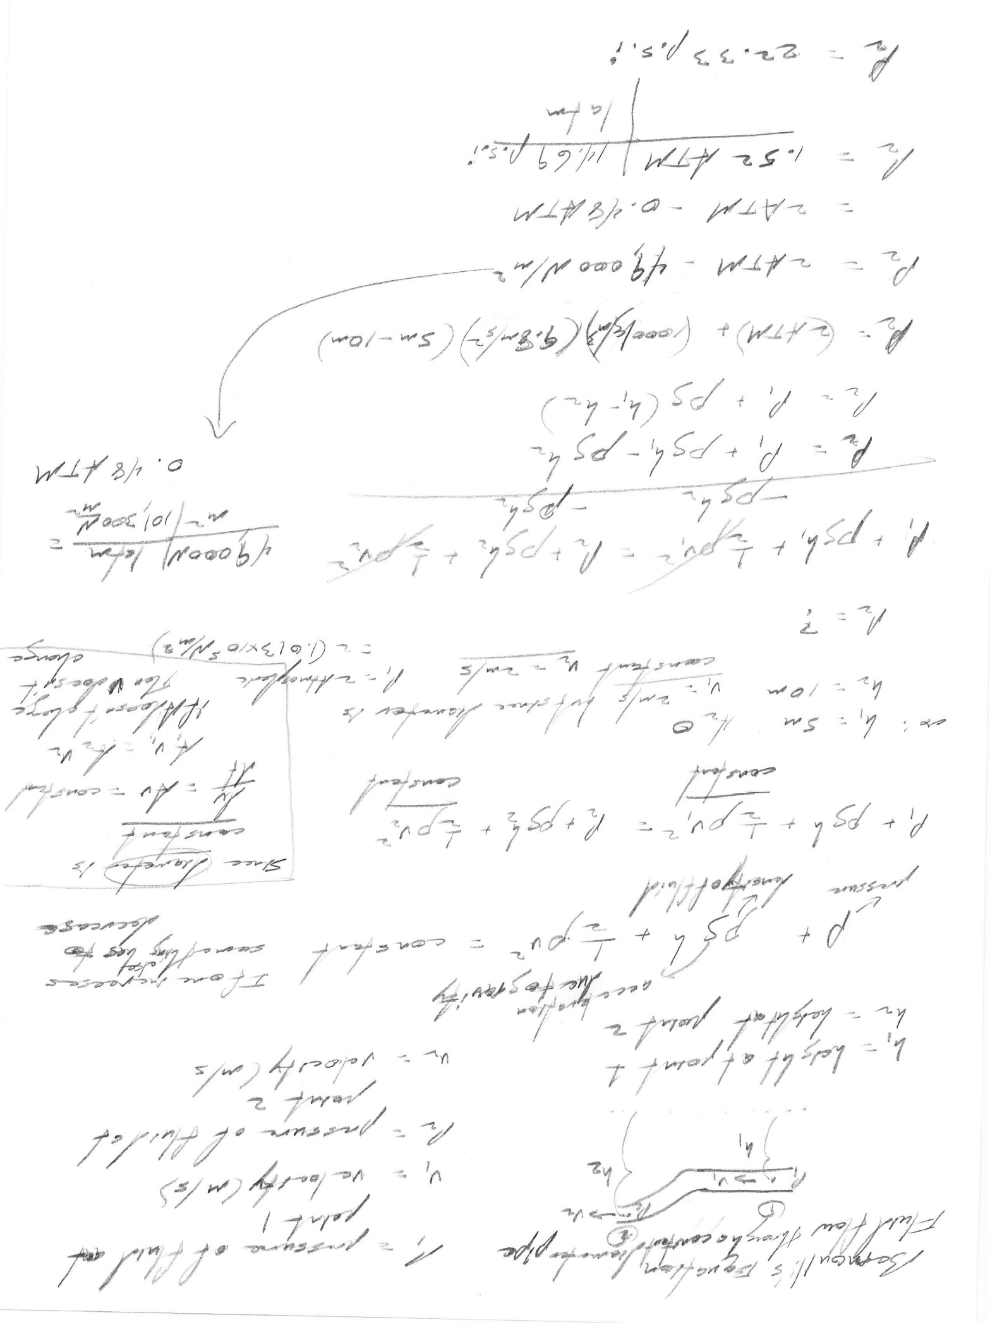
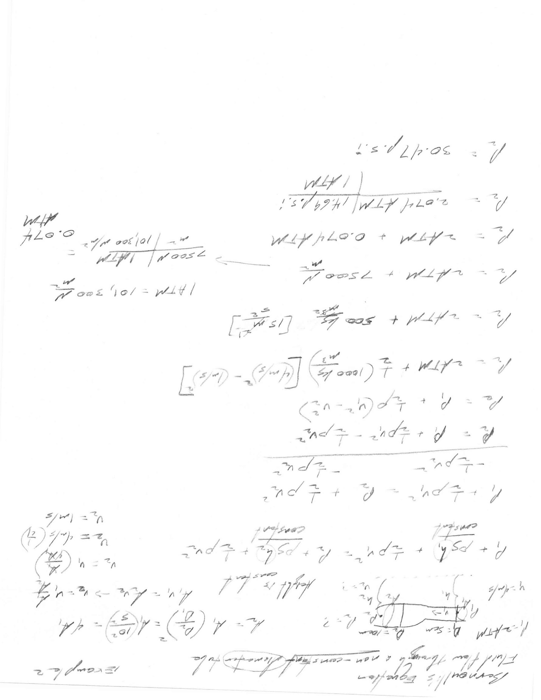
The techniques and method are listed and stated within the written protocol under (A). However, the point of the experiment is to assess the pressure at point (P2) within the confines of the barrel lining and spray head. The experiment dealing with pressure flows in response to a supplied unit of CO₂, is to assess whether or not from the design a pressure of <10 p.s.i is ejected from the spray head. In order for the solution pressure to arrive on the skin, it must be no greater than 10 p.s.i. If the pressure exceeds 10 p.s.i, the patient would experience a painful and harmful injection of the substance into the underlying layer of the epidermis. Therefore, the question posed is whether the pressure system devised for the SprAid, is sufficient enough to deliver a spray of <10 p.s.i. The hypothesis to correlate this response is: If the pressure does not exceed 10 p.s.i but remains within the confines of those parameters, then the spray will be efficient enough to deliver each of the solutions onto the skin without harming the patient.
The criteria for completion and special considerations will be discussed and empathized in this section. Completion of the pressure measurement for fluid flow will require a closed room facility to outside personnel. Each member will be tasked with a specific item including; recorder, measurements and calculations. The recorder will take the readings of the p.s.i level at point (P1) along with the time frame of how long it takes for the CO₂ to fully deplete. Measurements, will accurately note the height, pressure, fluid density and velocity. Calculations, will plug in the formula with all known variables into Bernoulli’s equation and use example one and two as a template in order to calculate the pressure at point (P2). The amount of time in order to complete the process and graph the results is one day. However, if predicaments arise in regards to malfunctions in the pressure gauge or any other equipment then the time frame of completion will be extended to one more day. Special considerations include resource material, MatLab and availability of team members. In regards to resource material, CO₂ canisters must be purchased in bulk in order to run multiple experiments. MatLab must be made available to the team members in order to plot the data gathered from the experiment. Time schedules must be calibrated in advance in order to assure assignment role confirmation and the availability of team members for a successful experiment.
The expected measurements for the experiment will include pressure readings in units of p.s.i. in regards to pressure release from the spray head at point (P2) and pressure readings at point (P2) of the inner lining of the barrel. The experimental results most allocate the following parameters in order to state that the spray system is safe and effective on the epidermal layer of the skin: one, that the pressure released from the spray head over time is <10 p.s.i, second the pressure is maintained throughout the inner-workings of the barrel as it travels from the source to the spray head and third, there are no leaks in the diameter lining of the barrel or spray head that would cause an explosion to harm both user and patient. Therefore, the expected results will show, if the system is designed correctly that the pressure is maintained within the specified range over time (<10 p.s.i) along with no residual leaks or explosions.

Safety Test

It is fundamental to perform an electrical safety test on our medical device to test the protective bonding. This is an electrical bond test to examine the product’s ground circuit. The question we want to test is what are the highest rated currents that the product can handle and if the protective devices of the circuit can protect device when there is a short circuit. The safety ground has to be able to handle any abnormal current that is induced on it. The safety ground is supposed allow all the circuit’s fuses or circuit breaker to open when the fault current flows through them. In order for the electrical circuit to function effectively, there must be continuity between the conductive components and the product’s ground terminal. The data gathered in this experiment will be used to analyze the safety ground on the SprAid device.

An experiment will be carried out using a ground bond tester as shown in Figure 1 by placing a current on the ground pin of the circuit. Next, we will measure the voltage drop across the safety ground circuit and calculate the impedance of the circuit. The testing parameters will include varying the current to determine the time, voltage drop, and necessary resistance high limit. The experiment will require the use of a Kelvin sense, a multimeter, a pulse generator and an oscilloscope. It is expected that the device will be able to handle currents up to 25 Amps. Nevertheless, the results will allow us to formulate a more effective ground terminal to protect the internal circuitry.
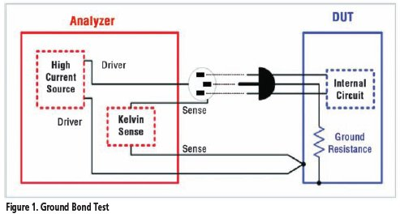
Sharp, Larry. The Why, When and How of Electrical Safety Testing. September 2010. http://www.evaluationengineering.com/articles/201009/the-why-when-and-how-of-electrical-safety-testing.php

